**Lesson 5**

* Comments on previous lesson.
* Today’s lesson activities.
* Do the activities on this document and upload it on POLIFORMAT – TAREAS.
* Deadline: During today’s class time

**Practice 5 - Transport**

**Listening**

You’re going to hear a talk about cycling. You will hear the talk twice. The first time, just listen. Try to understand generally what the speaker is talking about.

The task will play once

**Can you tell me in one or two sentences what the speaker was talking about?**

She speaks about disadvantages and advantages about cycling. She starts telling us some disadvantages and finishes the audio speaking about advantages of using a bike.

Now listen to the talk again. This time make some notes as you listen. Then I’ll ask you to tell me what the speaker says the advantages and disadvantages of cycling are. Are you ready?

The task will play once.

**Now write down what the speaker says the advantages and disadvantages of cycling are.**

✘ Dangerous, accidents, people ignore rules, its not practical for everybody, a decent one is expensive plus equipment. Country with extreme temperatures.

✓ Cheap, healthier, more interesting than a gym membership, good for mind and body. Reduce traffic congestión and pollution.

Record a **1.5-MINUTE FLIPGRID** in which you tell me what the advantages and disadvantages of cycling are according to the recording and give your opinion about it. I’ll stop you after one minute and a half.

* **Use contrast connectors**
* **Use expressions to report what has been said in the recording (‘as they say…’, ‘according to…’ . ‘as he explains’)**
* **Use opinion expressions**

**Speaking**

**Discuss the ideas in the interaction and the questions below in your assigned chat rooms. Make a decision. Record the interaction in the chat rooms. Interaction (3 minutes in pairs / 4 minutes groups of 3):**

* **Use agreeing and disagreeing expressions**
* **Use expressions to summarise the main conclusions**
* **Remember to show interest, invite people to speak, react to what others say**

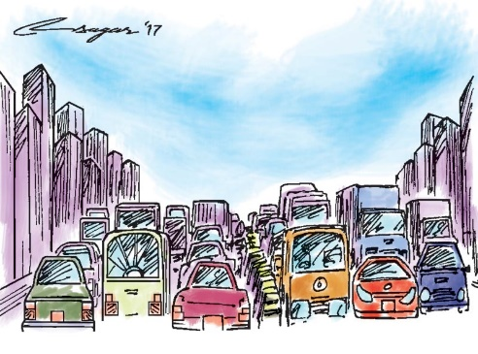**A. What are the advantages and disadvantages of these measures to improve the traffic flow in a city? Which is the best one?**

* How do you prefer to get round the city? Why?
* Have you ever experienced any traffic problems? Which ones? / How would you feel if you experienced them?

**Listening**

**Listen to a recording about how Sweden improved their road safety. Answer the questions:**

1. What cause the number of deaths to double?

-Head on collisions because they drive in the left road and cant see the right one.

1. What was the big change the government made?

-Switch from left to right.

1. What infrastructure changes took place?

-change road signs

- create special team to make sure it is done.

-speed limits reduced

-added new speed limits in places they have not existed

-Made an own song to help drivers.

1. What did the Swedish Royal Safety Agency achieve?

-lowered speed limits, seat belts and motorcycle helmet laws.

-

1. Why was it possible to reduce the number of fatalities?

-Separated cars from cyclists

-Invested a lot of money in the roads to improve them

1. What is the ultimate goal they have?

-Vision zero. No dead zones.

**Speaking**

**Discuss the ideas in the interaction and the questions below in your assigned chat rooms. Make a decision. Record the interaction in the chat rooms. Interaction (3 minutes in pairs / 4 minutes groups of 3):**

* **Use agreeing and disagreeing expressions**
* **Use expressions to summarise the main conclusions**
* **Remember to show interest, invite people to speak, react to what others say**

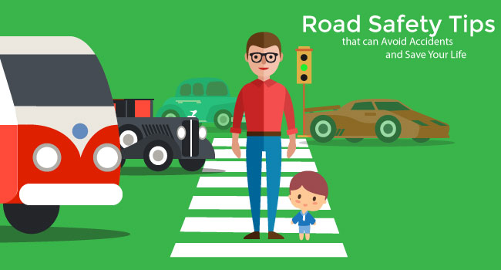**B. How could you increase road safety in your town? Which is the best one?**

* Do you drive? Do you enjoy it? Why / Why not? If you don’t drive, would you like to? Why / Why not?
* How do you feel about the quality of driving in your country? What about other countries you have visited or you have heard of?